STUDIO |  | SKIN ANALYSIS

Skin Analysis
Map what you see, then build the plan around it.
Client |  | Date |  | Esthetician

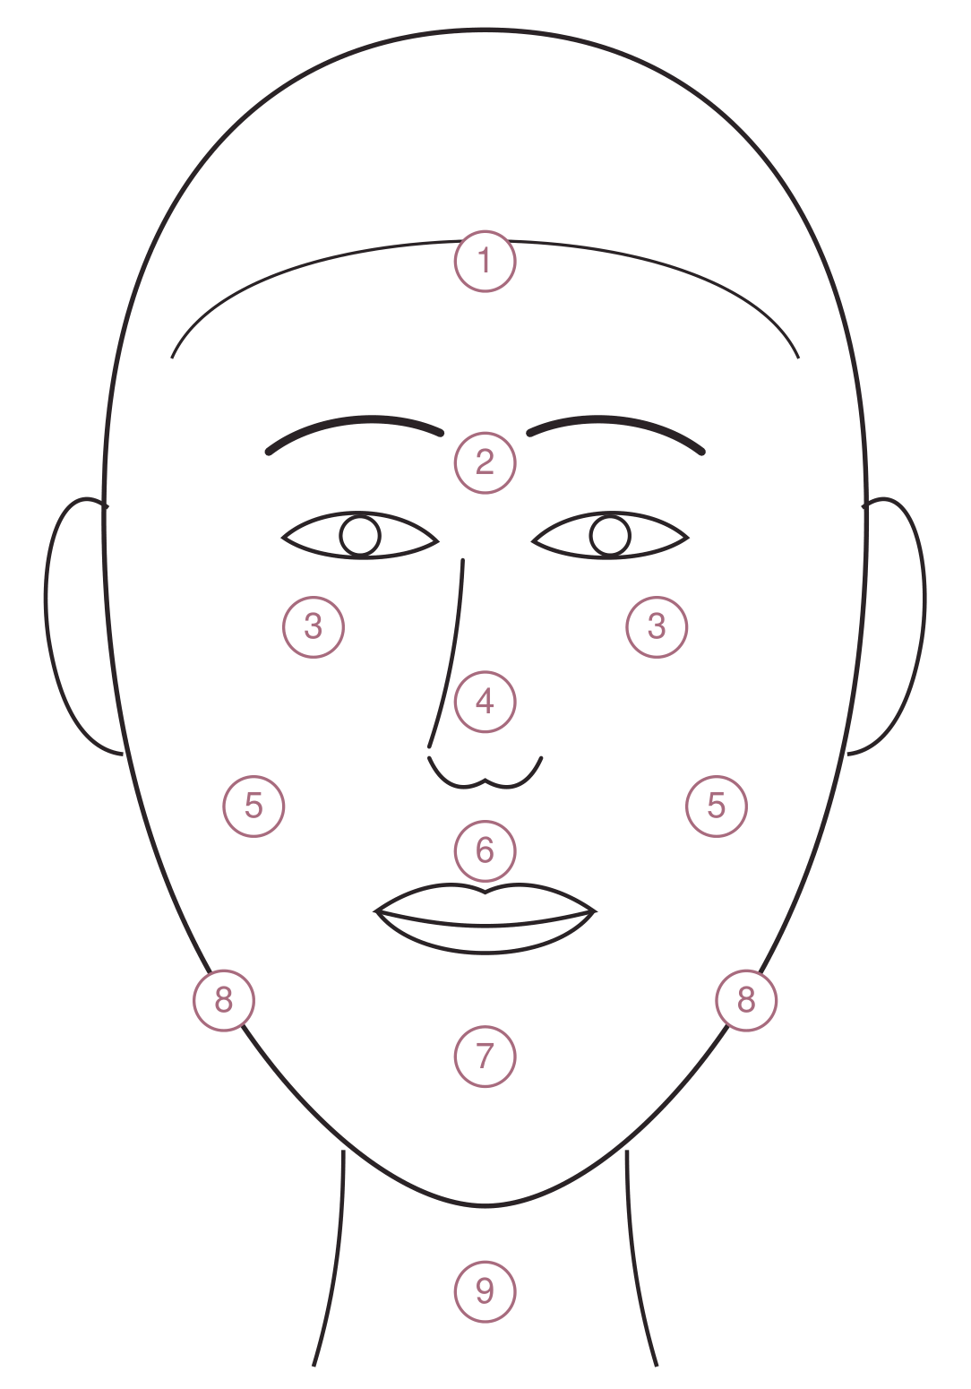  Zones: 1 Forehead · 2 Between the brows · 3 Eye area · 4 Nose · 5 Cheeks · 6 Upper lip · 7 Chin · 8 Jawline · 9 Neck  DRAW ON THE MAP | SKIN TYPE  FITZPATRICK  GLOGAU (AGING)  TODAY  Hydration  Oil  Sensitivity  Pores  CONCERNS
  MARK | MEANING | MARK | MEANING
  ● | Open comedones (blackheads) | R | Redness
  ○ | Closed comedones | T | Broken capillaries
  A | Papules, pustules (acne) | D | Dehydration lines
  M | Milia | W | Fine lines, wrinkles
  H | Hyperpigmentation | S | Scarring
  ☐ Normal | ☐ Dry | ☐ Oily
  ☐ Combination | ☐ Sensitive
  ☐ I | ☐ II | ☐ III | ☐ IV | ☐ V | ☐ VI
  ☐ I · none | ☐ II · in motion
  ☐ III · at rest | ☐ IV · all over
  ☐ Good | ☐ Fair | ☐ Low
  ☐ Low | ☐ Balanced | ☐ High
  ☐ Low | ☐ Moderate | ☐ High
  ☐ Fine | ☐ Visible | ☐ Enlarged
  ☐ Acne | ☐ Congestion | ☐ Dark spots
  ☐ Melasma | ☐ Redness | ☐ Rosacea
  ☐ Dehydration | ☐ Fine lines | ☐ Laxity
  ☐ Scarring | ☐ Sun damage | ☐ Ingrowns

THE PLAN
In the studio: treatments and how often | At home: morning and evening

Products recommended |  | Next visit

STUDIO |  | TREATMENT RECORD

Treatment Record
One line per visit. Keep it with the client's intake and consent forms.
Client |  | Date of birth |  | Phone

Cautions (allergies, medications, contraindications)

DATE | SERVICE | PRODUCTS AND STRENGTH | TIME OR LAYERS | SKIN RESPONSE | HOME CARE GIVEN | INIT.

STUDIO |  | PROGRESS MAP

Progress Map
Compare the skin at the start of a series with where it is now.
Client |  | Goal

BEFORE  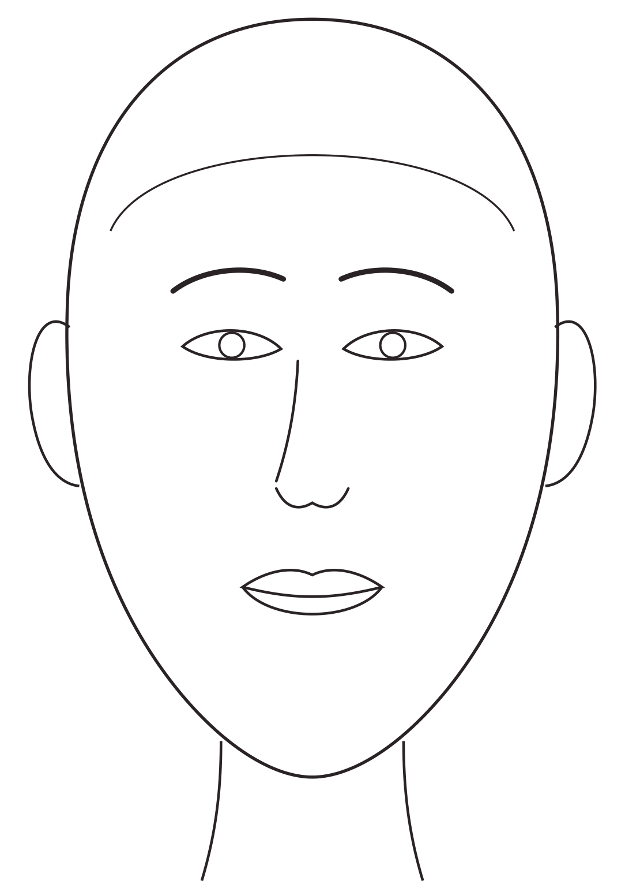  What I see | NOW  What's changed
  Date |  | Visit
  Date |  | Visit

PHOTOS
☐ Front | ☐ Left side | ☐ Right side | ☐ Same light and distance | ☐ Client consent on file

NEXT STEPS

